**TITANIC DATASET ANALYSIS**

1. **Survival Rates**:
   * What was the overall survival rate?

The overall survival rate was 39% which means that 39% of the passengers survived the titanic.

* + Did survival rates differ by passenger class, gender, or age group?

**Survival rate by passenger class:**

|  |  |  |
| --- | --- | --- |
| **Passenger class** | **Survival rate** | **Death rate** |
| First class | 62.96% | 37.04% |
| Second class | 47.28% | 52.72% |
| Third class | 24.44% | 75.56% |
| Grand totals | Overall survival rate | Overall death rate |

The overall survival rate by class is lower than the death rate for all classes and this indicates that a large number of passengers did not survive the titanic.

**Survival rates by gender:**

|  |  |  |  |
| --- | --- | --- | --- |
| **Survival** | **Alive** | **Dead** | **Grand Total** |
| **female** | **68%** | **14.86%** | **35.40%** |
| **male** | **31.87%** | **85.14%** | **64.60%** |
|  | **Overall survival rate** | **Overall death rate** | **100.00%** |

68% of the females survived while only 31% of the males survived. This means that there was a higher likelihood to survive if one was female than male.

Survival by age group:

|  |  |  |
| --- | --- | --- |
| Age groups | Alive | Dead |
| 1 ( 0-18) | 23% | 16% |
| 2 (19- 36) | 52% | 56% |
| 3 (36 - 54) | 22% | 22% |
| 4(55+) | 4% | 6% |
| Grand Total | Overall survival rate | Overall death rate |

Most of the age groups have a lower survival rate than death rate other than the age group 3 which has the same survival and death rate.

1. **Demographic Breakdown**:
   * How did age affect survival?

|  |  |  |  |
| --- | --- | --- | --- |
| **Age category** | **Alive** | **Dead** | **Grand Total** |
| Young (0 - 36) | 40% | 60% | 100% |
| Old (36+) | 36% | 64% | 100% |
| Grand Total | 39% | 61% | 100% |

All the age rates have a lower survival rate than the death rate.

* + Did families (using SibSp and Parch) have better survival rates?

1. **Economic Insight**:
   * Did paying a higher fare increase the chances of survival?

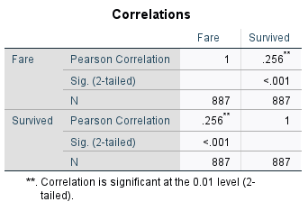

There is a weak positive correlation between the amount of fare paid and the survival rate.